**Jhenrich Roquios**

Aspiring Software Developer

A graduate with a Bachelor's degree in Computer Science, with prior knowledge and experience in the development field. I have knowledge of both computer hardware and software, along with a strong foundation in computer programming, technology, software development, and web development. I also have experience with version control and collaborative development.





**Contact Professional Experience**

**2023-08- Intern/ Back End**

**2023-09** Philippians Marketing Corporation - Dasmarinas, Province Of Cavite, Philippines

* Worked as a Back-end Developer on the web development project named "CHAMP Hub."
* Created user stories for the web pages to outline feature requirements and functionality.
* Collaborated on version control using GIT repositories and adhered to the Software Development Life Cycle (SDLC) approach.
* Developed the website using the Laravel framework with a TALL Stack approach (Tailwind CSS, Alpine.js, Laravel, Livewire).
* Assisted with IT help desk tasks, including system cloning, computer setup and relocation, and cleaning of system units.

**Address**

Gen. Mariano Alvarez, Province Of Cavite, Philippines 4117

**Phone**

+63 950 473 8498

**E-mail**

jhenrichroquios000@gmail.com

**WWW** https://bartzabelll.github.io/Portfolio/

**WWW** https://github.com/Jhenrichjr





**Skills Education**

**2024-09 Bachelor of Science in Computer Science**

Cavite State University - Carmona Campus Carmona, Province Of Cavite, Philippines

**Technical Skills:**

**Programming Languages:**

* PHP, JavaScript, HTML, CSS / Tailwind CSS, Python, Java

**Web Development:**

* Laravel Framework: Experience in developing web applications using the Laravel framework, following a TALL stack approach (Tailwind CSS, Alpine.js, Laravel, Livewire).

**2023-09** IT Department Training - Back End Web Developer

**Certifications**



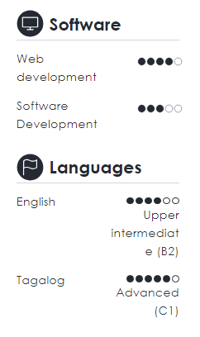

* Database Management: Skilled in database migrations and designing database schemas using MySQL.
* Version Control: Proficient in using Git for version control, including creating and managing repositories, branches, and collaborative workflows.

**Software Development:**

* Experience in creating user stories and working through the Software Development Life Cycle (SDLC).
* Knowledge of collaborative development practices and tools.
* Proficient in creating diagrams for system and data relationships.
* Hardware and IT Support:
* Hardware Skills: Capable of building computers, installing software, and performing minor troubleshooting and networking tasks.
* IT Help Desk Support: Experience in system cloning, computer setup and relocation, and cleaning system units.

**Additional Skills:**

* Problem-solving and analytical thinking
* Team collaboration and communication